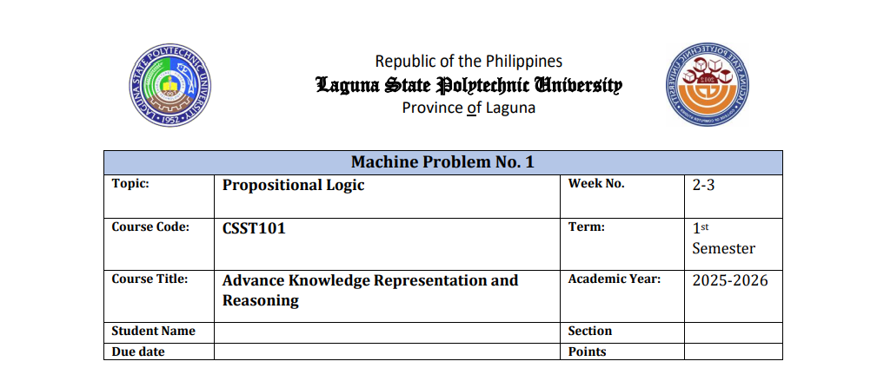  
  
  
  
  
  
  
  
  
  
  
  
  
**Rule-Based Reasoning and Expert Systems**

**8**

**Rule-Based Reasoning and Expert Systems**

**Name: Shaila Patrice D. Avellaneda**

**Section BSCS 3A**

**Assessment / Discussion Forum**

**Questions**

1. How is rule-based reasoning different from statistical or learning-based AI methods?

* Rule-based reasoning uses **clear, fixed rules** made by people (like “If the laptop is slow → suggest upgrading RAM”). Learning-based AI (like machine learning) uses **data to learn patterns** by itself — it improves over time instead of following prewritten rules.

1. What are some real-life examples of rule-based systems?

* Chatbots that answer common questions
* Medical tools that suggest possible sicknesses

1. What advantages do rule-based systems offer in terms of explainability?

* Rule-based systems are **easy to understand** because you can see **exactly which rule** was used. You can clearly explain why the system gave that answer, making it simple to check or fix if something goes wrong.

1. Modify your R program to include one new rule of your own.
2. cat("============================================\n")
3. cat("Welcome to the Laptop Troubleshooting Assistant!\n")
4. cat("============================================\n\n")
5. cat("Please describe your issue or choose from examples below:\n")
6. cat("------------------------------------------------------------\n")
7. cat(" • battery not charging\n")
8. cat(" • laptop is slow\n")
9. cat(" • laptop overheating\n")
10. cat(" • wifi not working\n")
11. cat(" • screen not displaying\n")
12. cat("------------------------------------------------------------\n\n")
13. issue <- tolower(readline(prompt = "Enter issue: "))
14. if (grepl("battery", issue) && grepl("not charging", issue)) {
15. advice <- "Check your power adapter or battery connection."
16. } else if (grepl("slow", issue)) {
17. advice <- "Try closing unused programs or upgrading your RAM."
18. } else if (grepl("overheat", issue)) {
19. advice <- "Clean your laptop’s fan and ensure proper ventilation."
20. } else if (grepl("wifi", issue)) {
21. advice <- "Restart your router or update your Wi-Fi drivers."
22. } else if (grepl("screen", issue)) {
23. advice <- "Check the display cable or connect to an external monitor to test."
24. } else {
25. advice <- "Issue not recognized. Please contact technical support."
26. }
27. cat("\n============================================\n")
28. cat("Advice:", advice, "\n")
29. cat("============================================\n")